Feasibility Evidence Description (FED)

<Project Title>
基于Spark的成绩分析推荐系统

<Team No>

Team 3

<Team members and roles>

纪鸿旭：产品经理/算法工程师
许云峰：项目经理/系统架构师
张 培：视觉设计师/数据分析师
刘航舟：服务端开发工程师/测试工程师

March 11,2017 <Date>

Version History
Date | Author | Version | Changes made | Rationale
03/12/17 |  | 1.0 | - 实现了简易的App，第一模块能够初步使用 | - 第一模块：用户能够通过App登陆云南大学urp
03/26/17 |  | 1.0.1 | - 改变了APP的第二模块 | - 第二模块显示课程搜索等界面（暂时还不能搜索）

Table of Contents
Feasibility Evidence Description (FED) i
Version History ii
Table of Contents iii
Table of Tables iv
Table of Figures v
1. Introduction 1
1.1 Purpose of the FED Document 1
1.2 Status of the FED Document 1
2. Process Feasibility 2
3. Risk Assessment 3
4. NDI/NCS Feasibility Analysis 4
4.1 Assessment Approach 4
4.2 Assessment Results 4
4.3 Feasibility Evidence 6
5. Business Case Analysis 8
5.1 Market Trend and Product Line Analysis 8
5.2 Cost Analysis 8
5.3 Benefit Analysis 9
5.4 ROI Analysis 9
6. Conclusion and Recommendations 11

Table of Tables
Table 1: Rationales for Selecting Architected Agile Model 2
Table 2: Requirement Prioritization 2
Table 3: Risk Assessment 3
Table 4: NDI/NCS Products Listing 4
Table 5: Evaluation Criteria – NDI /NCS Attributes 4
Table 6: Evaluation Criteria - NDI/NCS features 5
Table 7: Evaluation Results Screen Matrix 5
Table 8: Level of Service Satisfiability Evidence 6
Table 9: Level of Service Implementation Strategy 6
Table 10: Capability Feasibility Evidence 6
Table 11: Evolutionary Feasibility Evidence 7
Table 12: Market Trend and Product Line Analysis 8
Table 13: Personnel Costs 8
Table 14: Hardware and Software Costs 9
Table 15: Benefits of xxx System 9
Table 16: ROI Analysis 9

Table of Figures
Figure 1: ROI Analysis Graph 10

Introduction

Purpose of the FED Document
<< Discuss the purpose of the FED>>

这个FED文档提供了整个工程的技术可能性分析，风险分析，NDI/NCS可能性分析和商业案例分析。其目的是论证整个项目是可行的，并且能够在计划的时间和预算内实现。

Status of the FED Document
<< Discuss the status of the FED especially key differences from the previous version, for example
- The risk of possible components mismatch has been removed
- The client postponed the hardware acquisition to next fiscal year and business case analysis is updated accordingly. >>
<03/06/17-03/12/17>
- 小组讨论课题，分析课题的可行性，最终确定课题——基于Spark的成绩分析推荐系统。
- 实现了简易的APP，第一模块如下图所示：


<03/13/17-03/26/17>
- 小组学习网易云课堂部分spark课程，探索数据处理模式和服务器模式。
- 实现APP第二模块的搜索界面（暂时不能搜索课程及老师），界面如下图所示：

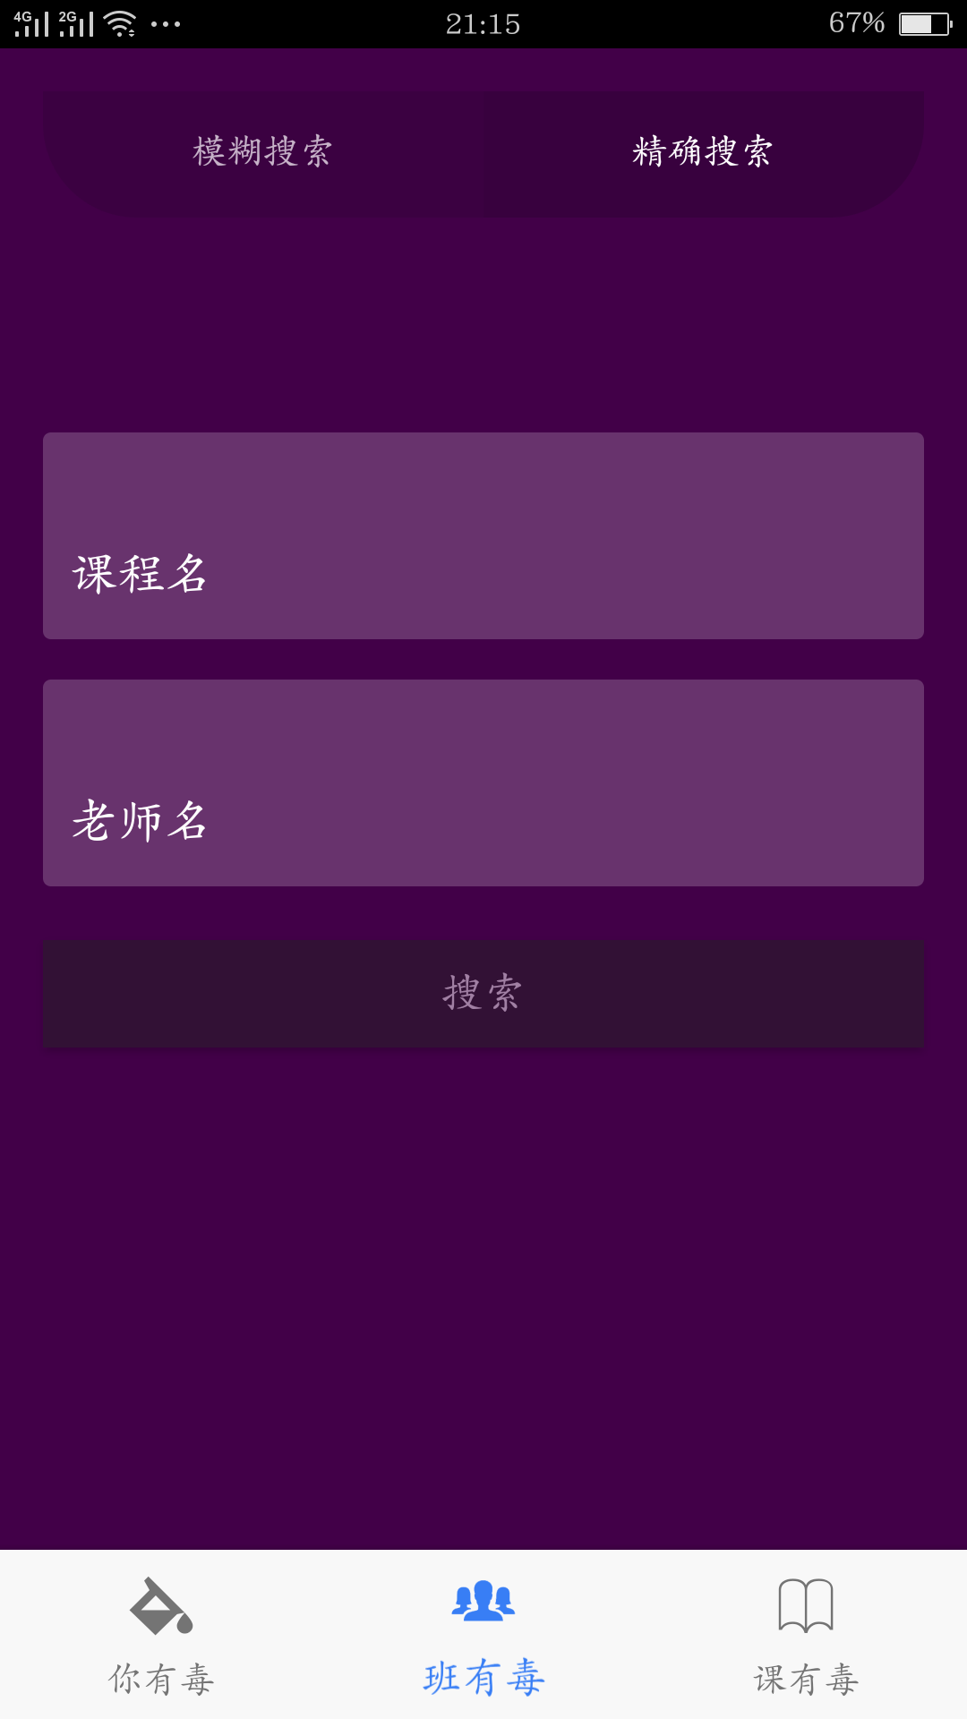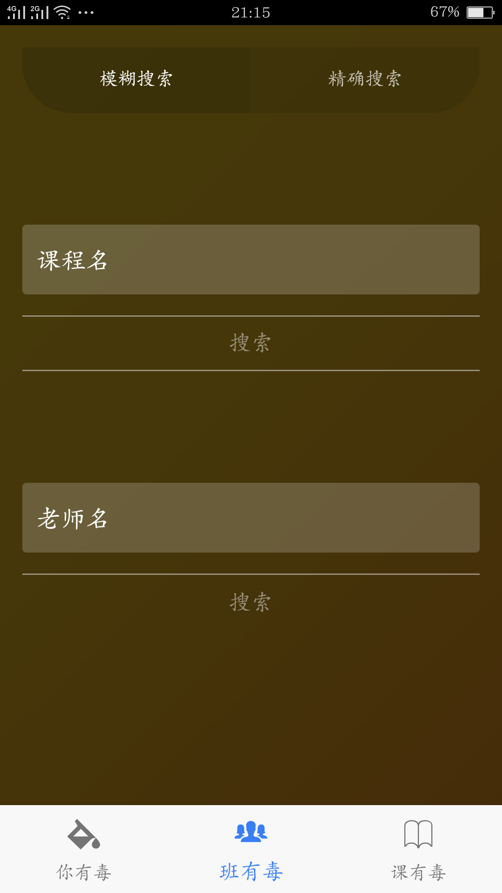

Process Feasibility
<< Based on process decision table provided in ICM EPG> Concept: Process Decision Selection Guidelines, Identify which process model you are following and provide rationale why that model would fit your development project. >>
Table 1: Rationales for Selecting Architected Agile Model
Criteria | Rationales
Size, Complexity | 中型实训项目，复杂性较高
Change Rate % /Month | 30%
Criticalit | 对于数据的分析处理
NDI Support | spark，ionic2，angular2，typescript，node，npm，cordova，chartjs，webpack，scss
Org/Personnel Capability
Key Stage I Activities : Incremental Definition | 实现APP模型，对成绩数据进行分析处理
Key Stage II Activities: Incremental Development, Operations | 将数据处理与APP结合起来，实现一个具有个人成绩分析，教学班成绩分析和课程推荐功能的APP
Time per Build;  Time per Increment | 每周一次

<< For NDI-Intensive and Net-Centric Services projects, if you have to develop some glue code or custom code, please note that since CSCI577ab has a fixed schedule, so we follow the concept of schedule as independent variable (SAIV). Explain how many module you have to custom code or glue code and how your team plans to implement all the required modules to make your project feasible. For example, you may plan to implement all must-have priority requirements in first increment and should-have priority requirements in the second iteration>>

Table 2: Requirement Prioritization
Priority | Requirements | References | Increment #
1 | 个人成绩分析
2 | 教学班成绩分析
3 | 课程推荐

Risk Assessment
<< Identify our project risk, its exposure and its mitigation plan. Please note risk is a threat or probability that something will happen and possibly create loss or injury. So, if your threat or your incident is already happened, then it is a problem, not a risk. More example of risks can be found at ICM EPG> Task: Assess and Plans to Mitigate Risks>>
Table 3: Risk Assessment
Risks | Risk Exposure |  |  | Risk Mitigations
Risks | Potential Magnitude | Probability Loss | Risk Exposure | Risk Mitigations
对软件要求的不准确理解 | 3 | 3 | 9 | 团队内部进行讨论，确保每个成员都能理解正确的需求
需求的变化 | 3 | 3 | 9 | 计算花费，增量发展
个人能力不足 | 4 | 6 | 24 | 自我学习，向其他同学请教
服务端更改 | 4 | 4 | 16 | 自学，知识转化，增量发展
系统设计接口和人机交互问题 | 3 | 7 | 21 | 增量发展，结合用户的反馈

NDI/NCS Feasibility Analysis

Assessment Approach
<< Identify the approach in assessing NDI/ NCS component candidates. Discuss the instruments and facilities that you are using.>>
该部分用于介绍项目所运用的开源、网络组件。
1、Spark
Spark 是一种与 Hadoop 相似的开源集群计算环境，但是两者之间还存在一些不同之处，这些有用的不同之处使 Spark 在某些工作负载方面表现得更加优越，换句话说，Spark 启用了内存分布数据集，除了能够提供交互式查询外，它还可以优化迭代工作负载。
Spark 是在 Scala 语言中实现的，它将 Scala 用作其应用程序框架。与 Hadoop 不同，Spark 和 Scala 能够紧密集成，其中的 Scala 可以像操作本地集合对象一样轻松地操作分布式数据集。

2、Ionic2
ionic的设计初衷是帮助web程序员以较低的学习成本上手app开发，这种混合开发模式 使得制作app就像构建一个网站那样简单。ionic的核心技术是web开发中常用的html＋css＋javascript，这些技术已经存在了20多年，至今依然茁壮成长。和ionic 1一样，你可以通过命令行或者图形化工具来安装和构建ionic 2，同时可以在浏览器中测试ionic 2程序。

- Angular2
AngularJS 最初由Misko Hevery 和Adam Abrons于2009年开发，后来成为了Google公司的项目。AngularJS弥补了HTML在构建应用方面的不足，其通过使用标识符（directives）结构，来扩展Web应用中的HTML词汇，使开发者可以使用HTML来声明动态内容，从而使得Web开发和测试工作变得更加容易。

- Typescript
TypeScript是一种由微软开发的自由和开源的编程语言。它是JavaScript的一个超集，而且本质上向这个语言添加了可选的静态类型和基于类的面向对象编程。

- Node
Node.js是一个Javascript运行环境(runtime)。实际上它是对Google V8引擎进行了封装。V8引 擎执行Javascript的速度非常快，性能非常好。Node.js对一些特殊用例进行了优化，提供了替代的API，使得V8在非浏览器环境下运行得更好。

- Npm
NPM的全称是Node Package Manager ，是一个NodeJS包管理和分发工具，已经成为了非官方的发布Node模块（包）的标准。
- Cordova
Cordova提供了一组设备相关的API，通过这组API，移动应用能够以JavaScript访问原生的设备功能，如摄像头、麦克风等。
Cordova还提供了一组统一的JavaScript类库，以及为这些类库所用的设备相关的原生后台代码。

- Chartjs
基于 HTML5 的 JavaScript 图表库

- Webpack
WebPack可以看做是模块打包机：它做的事情是，分析你的项目结构，找到JavaScript模块以及其它的一些浏览器不能直接运行的拓展语言（Scss，TypeScript等），并将其打包为合适的格式以供浏览器使用。

- Scss
SASS是CSS3的一个扩展，增加了规则嵌套、变量、混合、选择器继承等等。通过使用命令行的工具或WEB框架插件把它转换成标准的、格式良好的CSS代码。
SCSS即是SASS的新语法，是Sassy CSS的简写，是CSS3语法的超集，也就是说所有有效的CSS3样式也同样适合于SASS。

Assessment Results

NDI/NCS Candidate Components (Combinations)
<< Identify all candidate commercial off-the-shelf, government-off-the-shelf, research-off-the-shelf, open source software, libraries, and net-centric services component that you are using/ plan to use. Also identify the purpose of each component. If you have to use multiple NDI/NCS to satisfy the objectives & constraints and priorities, group them in combination set. >>
Table 4: NDI/NCS Products Listing
NDI/NCS Products | Purposes
spark | 用于分析处理数据
ionic2 | 用于APP开发
angular2 | 使Web开发和测试工作变得更加容易
typescript | 用于编程
node | 使V8在非浏览器环境下运行得更好
npm | 帮助NodeJS包管理和分发
cordova | 移动应用能够以JavaScript访问原生的设备功能，如摄像头、麦克风等
chartjs | 用于图表的实现
webpack | 用于web开发
scss | 以少量的代码创建复杂的设计

Evaluation Criteria
<< Identify the evaluation criteria in term of NDI/NCS attributes. The full list of NDI/NCS attributes can be found at ICM EPG> Concept: NDI/NCS attribute. If the list does not cover the attribute that you are looking for, you can add / remove the attributes from the list. Assign weight of each evaluation criteria by discussing with clients and project team members. Make sure the total weight is 100. >>

Table 5: Evaluation Criteria – NDI /NCS Attributes
No. | Evaluation Criteria – NDI/NCS attributes | Weight
1 | spark
2 | ionic2
3 | angular2
4 | typescript
5 | node
6 | npm
7 | cordova
8 | chartjs
9 | webpack
10 | scss
 | Total | 100

<< The following table allows you to show how the candidate components (combination) will satisfy the capability/ product win conditions that have been negotiated in WinWin Negotiation. By using the capability win conditions and their priority, create list of features and their weight. The features could also be split into second level features if required. The weight of each features are from the priority of each win condition derived from WinWin negotiation. Make sure the total weight is 100. >>

Table 6: Evaluation Criteria - NDI/NCS features
No. | NDI/NCS Features/ sub features | Weight
1 | spark
2 | ionic2
3 | angular2
4 | typescript
5 | node
6 | npm
7 | cordova
8 | chartjs
9 | webpack
10 | scss
 | Total | 100

Evaluation Results Screen Matrix
<< The following table reports the results of components (combinations) evaluation based on features criteria and weight that has been defined in Table 5 and Table 6. You could have two evaluation results screen matrix; one is from Table 5 and the other one from Table 6. Assuming that you have 4 NDI/NCS evaluators (r1-r4), each person will evaluate and score on each feature. The score will be averaged and multiplied for the total score. Example can be found at ICM EPG> Task: Assess / Evaluate NDI/NCS components. >>

Table 7: Evaluation Results Screen Matrix
No | W | Component 1 |  |  |  | AVG | Total | Component 1 |  |  |  | AVG | Total | Component 1 |  |  |  | AVG | Total
No | W | R1 | R2 | R3 | R4 | AVG | Total | R1 | R2 | R3 | R4 | AVG | Total | R1 | R2 | R3 | R4 | AVG | Total
1
2
3
4
5
6
Total | 100

Feasibility Evidence
<< Provide evidence or rationale of why do you think the following LOS, capability, and evolutionary win conditions are satisfiable. Example of product and process strategies can be found in ICM EPG> Task: Provide Architecture Feasibility Evidence>>

Level of Service Feasibility
<< If the selected NDI/NCS’s performance satisfies level of service win condition, show the rationale or evidence that the LOS is achievable in Table 8>>
Table 8: Level of Service Satisfiability Evidence
Level of Service Win Condition | Rationale
LOS-x: << LOS name>> | << Provide evidence or rational to show that this Level Of Service win condition is achievable. >>

<< If the selected NDI/NCS’s performance does not satisfy level of service win condition, explain your product and process strategies of how to implement your system in order to satisfy the LOS win condition. Example of product and process strategies can be found in ICM EPG> Task: Provide Architecture Feasibility Evidence. >>

Table 9: Level of Service Implementation Strategy
Level of Service Win Condition | Product Satisfaction
LOS-x: << LOS name >> | Product Strategies: <<Identify product-related strategies that can make you achieve this requirement. >>
LOS-x: << LOS name >> | Process Strategies: <<Identify process-related strategies that can make you achieve this requirement. >>
LOS-x: << LOS name >> | Analysis: << Provide rationale to support your strategies>>
 | Product Strategies:
 | Process Strategies:
 | Analysis:

Capability Feasibility
Table 10: Capability Feasibility Evidence
Capability Requirement | Product Satisfaction
CR-1: << CR name >> | Software/Technology used: <<identify the software/technology that is/are used to develop this capability requirement>>
CR-1: << CR name >> | Feasibility Evidence: << briefly provide rationale of how this capability could be developed to satisfy the requirements. >>
CR-1: << CR name >> | Referred use case diagram: << identify related use case diagram >>
 | Software/Technology used:
 | Feasibility Evidence:
 | Referred use case diagram:
 | Software/Technology used:
 | Feasibility Evidence:
 | Referred use case diagram:

Evolutionary Feasibility
Table 11: Evolutionary Feasibility Evidence
Evolutionary Win Condition | Rationale
ER-x: << ER name>> | << Provide evidence or rational to show that this Evolutionary win condition is achievable. >>

Business Case Analysis

Market Trend and Product Line Analysis
<< Briefly analyze the market trend, product popularity, product market standpoint, predicted longevity of the company and etc. Also analyze the related products that are developed/ launched by the same company/ organization. >>

Table 12: Market Trend and Product Line Analysis
 | Component 1 | Component 2 | Component 3
Market Trend
Product Line

Cost Analysis
<< Identify all possible cost either in monetary term or hours spent for the project. Please note that you do not include the effort cost spent by development team, include only cost spent by clients. >>

Personnel Costs
<< Identify all personnel-related cost from exploration phase to operation phase. Example can be found at ICM EPG>Task: Analyze Business Case>>
Table 13: Personnel Costs
Activities | Time Spent (Hours)

Hardware and Software Costs
<< Identify all hardware and software-related cost from exploration phase to operation phase. Software costs could range from ownership cost, transition cost, operational cost, per license cost, and etc. >>

Table 14: Hardware and Software Costs
Type | Component 1 | Component 2 | Component 3
Type -1 << ownership cost>>
Total

Benefit Analysis
<< Analyze benefits from this project. Benefits could be in the quantitative form such as more revenue, saved effort, and qualitative form such as increase of reliability. Example can be found at ICM EPG>Task: Analyze Business Case>>

Table 15: Benefits of xxx System
Current activities & resources used | % Reduce | Time Saved (Hours/Year)
Total

ROI Analysis
<< Calculate Return of Investment by using your cost and benefit analysis results and identify the breakeven point. Note, if you have hardware and software cost, it must be included in ROI calculation. For effort cost, if you use a salary as your calculation base, assume 10% annually increase. Example can be found at ICM EPG>Task: Analyze Business Case>>
Table 16: ROI Analysis
Year | Cost | Benefit  (Effort Saved) | Cumulative Cost | Cumulative Benefit | ROI
Figure 1: ROI Analysis Graph
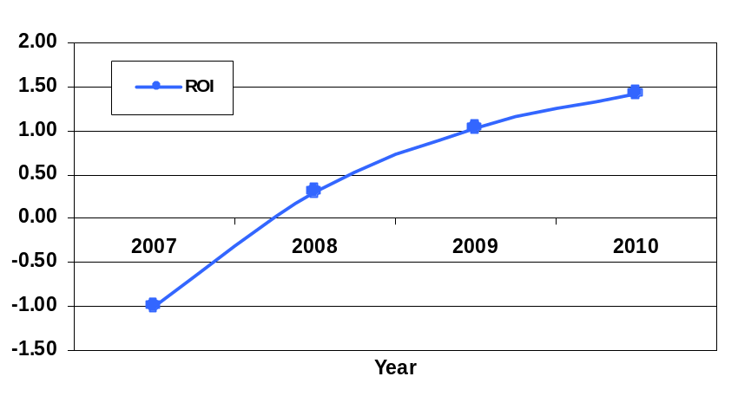

Conclusion and Recommendations
<< In general, it is best to organize these into (conclusion-recommendation) pairs, for example:
C1. Component 1 has by far the best performance, but runs only on Windows, failing the acceptable portability criterion. Component 2 is fully portable, and has acceptable performance.
R1. Use Component 2 for the oversize image viewer function.

C2. The DBMS assessment is still underway, and Component 2’s interoperability is still uncertain.
R2. Perform an interoperability assessment between Component 2 and the two DBMS finalists. >>

